Jmeter Fundamentals and Advanced Course Works

Contents

1. Week 6 Course Works: Throughput, Function Helper, Saving Test Result 4

# Week 6 Course Works: Throughput, Function Helper, Saving Test Result

* + **Running Clinique Login Test Plan with throughput goal 3 users/second for 10 seconds:**
  + To do the Performance Test with throughput goal 3/s in 10 seconds, we add “Constant Throughput Timer” under Thread Group. With this throughput, total users will be 30.
  + Run this Test Plan and write down the result:
    - What is the average response time?
    - What is the min response?
    - What is the max response?
    - What is the throughput data of the test?
    - Is there any error occur during the test? If it is, what is the percentage of error?

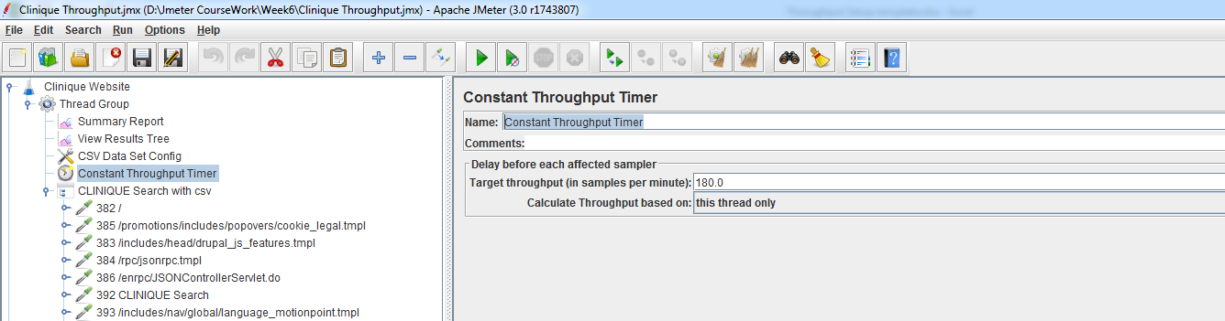

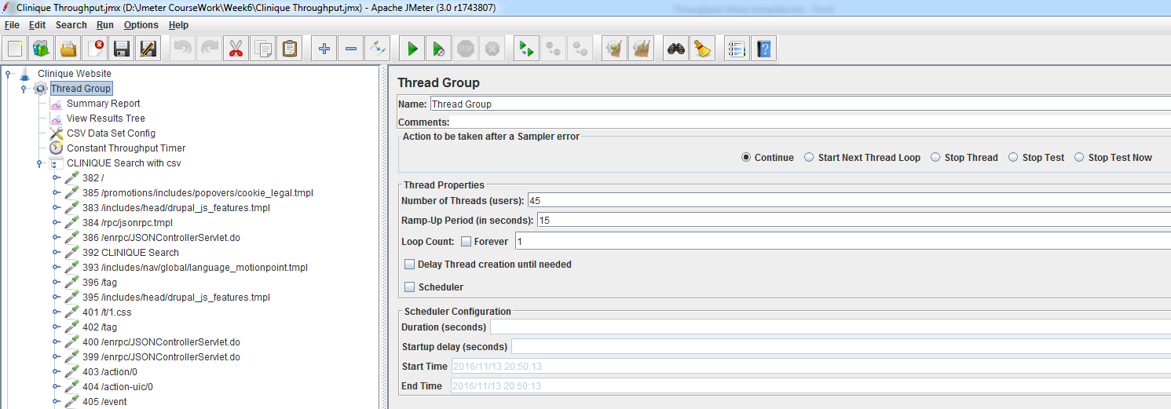

* + **Running Clinique Login Test Plan with throughput goal 3 users/second for 20 seconds:**
  + To do the Performance Test with throughput goal 3/s in 20 seconds, we add “Constant Throughput Timer” under Thread Group. With this throughput, total users will be 60.
  + Run this Test Plan and write down the result:
    - What is the average response time?
    - What is the min response?
    - What is the max response?
    - What is the throughput data of the test?
    - Is there any error occur during the test? If it is, what is the percentage of error?
  + **Running Clinique Login Test Plan with throughput Shaping Timer:**
  + To do the Performance Test with different throughput goal approach, we add “Throughput Shaping Timer” under Thread Group. Below is the goal of this performance Test.
  + Run this Test Plan and write down the result:
    - What is the average response time?
    - What is the min response?
    - What is the max response?
    - What is the throughput data of the test?
    - Is there any error occur during the test? If it is, what is the percentage of error?

|  |  |  |
| --- | --- | --- |
| **Start Throughput/second** | **End Throughput/second** | **Duration** |
| 1 | 3 | 10 |
| 3 | 3 | 20 |
| 3 | 4 | 10 |

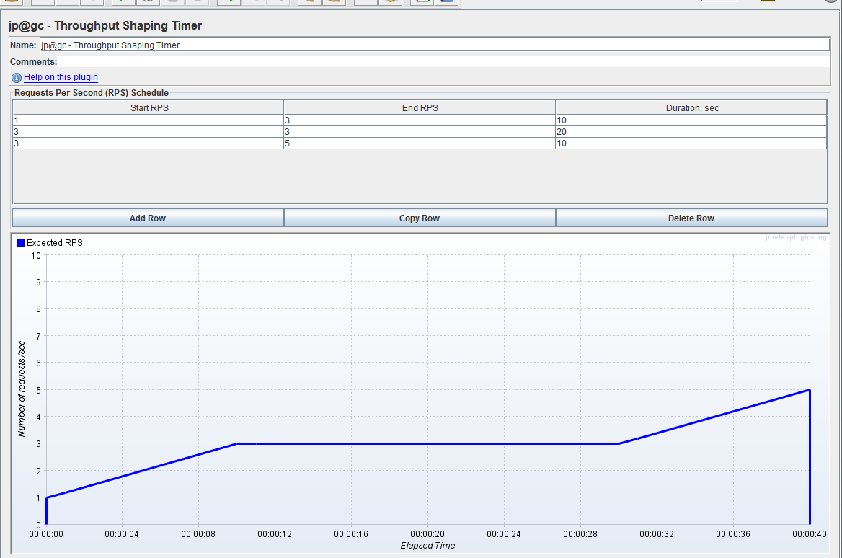

* + **Homework**: **Running Kijiji Login Test Plan with throughput goal 3 users/second for 10 seconds:**
  + To do the Performance Test with throughput goal 3/s in 10 seconds, we add “Constant Throughput Timer” under Thread Group. With this throughput, total users will be 30.
  + Run this Test Plan and write down the result:
    - What is the average response time?
    - What is the min response?
    - What is the max response?
    - What is the throughput data of the test?
  + Is there any error occur during the test? If it is, what is the percentage of error?
  + **Homework**: **Running Kijiji Login Test Plan with throughput Shaping Timer:**
  + To do the Performance Test with different throughput goal approach, we add “Throughput Shaping Timer” under Thread Group. Below is the goal of this performance Test.

|  |  |  |
| --- | --- | --- |
| **Start Throughput/second** | **End Throughput/second** | **Duration** |
| 1 | 3 | 10 |
| 3 | 3 | 20 |
| 3 | 4 | 10 |

* + Run this Test Plan and write down the result:
    - What is the average response time?
    - What is the min response?
    - What is the max response?
    - What is the throughput data of the test?
  + Is there any error occur during the test? If it is, what is the percentage of error?